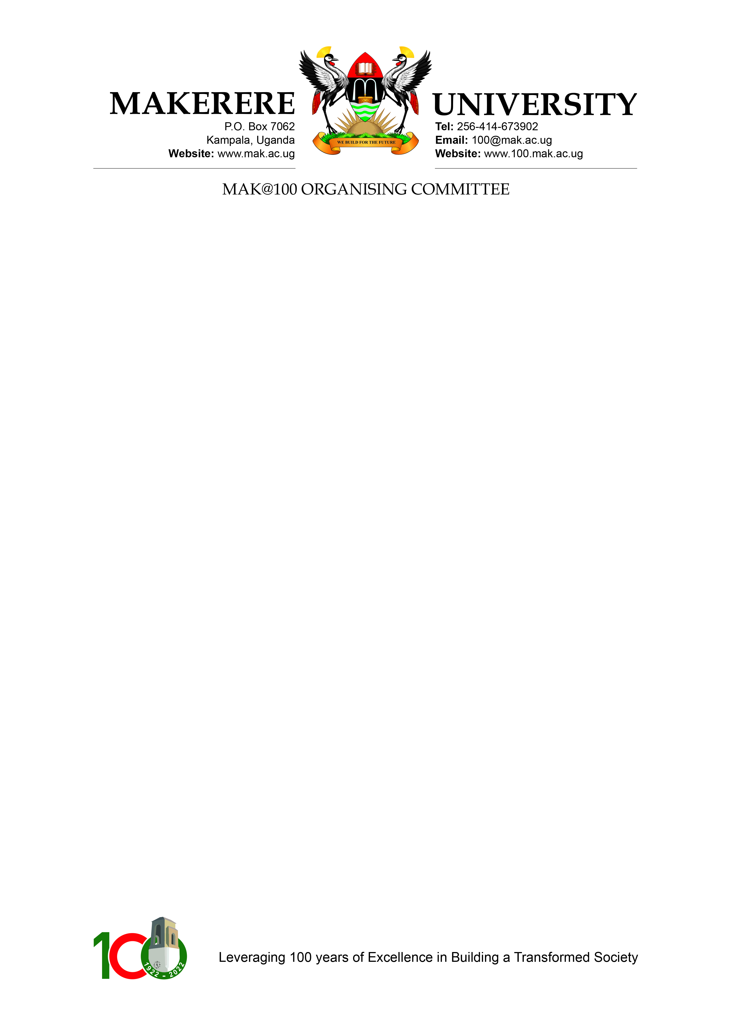

SPEECH BY THE CHAIRPERSON
MAK@100 COMMITTEE

- The First Lady & Minister of Education and Sports Hon. Janet Kataaha Museveni
- The Chairperson Makerere University Council
- Members of Council
- The Vice-Chancellor
- Members of Senior Management
- All protocols observed

Hon. Minister, it’s my pleasure to share with you a brief on the progress of planning and execution of activities on occasion of Makerere At 100 celebrations

On behalf of the organizing committee which is tasked to coordinate all the activities associated with the centenary celebrations, I take the special pleasure to thank you for facilitating the request to His Excellency for funding for the activities.

We extend our thanks to His Excellency the President for the offer to contribute 800 million shillings towards the budget activities for the Centenary celebrations

Hon. Minister and First lady, the climax of the celebrations will be held on the 08th October, 2022, on the eve of the 60th independence day celebrations for our great nation Uganda.

At this significant celebrations, we look forward to welcoming you and through your good office, we will invite His Excellency the President, and his colleagues from East Africa.

The commemoration and celebrations of Makerere at 100, includes hosting of series of activities including, public lectures, seminars, exhibitions, conferences, alumni events, district exhibitions, a centenary marathon, and conferences.

The climax event will be on 08th October, 2022.

Hon. Minister, we have already invited you for the Centenary conference scheduled to take place 27th – 28th of September, 2022, and look forward to receiving you for the same purpose.

As you will recall, the celebrations were launched by His Excellency the President, and yourself, on the 09th October, 2021 at Kololo grounds, on the sidelines of the 59th independence day celebrations.

Hon. First Lady, the Council approved a budget of 1,400,000,000 shillings to cater to events, activities, and publicity costs.

His Excellency the President pledged a contribution of 800,000,000 Million Shillings, and we thank you for your support in securing this pledge.

We have managed to mobilise the balance of the resources needed from corporate and private sector partners, some who include MTN Uganda, Stanbic Bank, Centenary Bank, ABSA Bank, UAP-Old Mutual, the Vision Group, among many others.

As part of the celebrations, we have also earmarked legacy projects to remind future generations of this significant moment in history, including university teaching hospital, and we are eternally grateful for your stewardship in negotiating the 300 million United States dollars for its construction.

The other projects include a student centre and students accommodations especially for girls and Masters students.

Hon. Minister, we look forward to your continued support achieving this ambitious agenda, and shall diligently keep you updated on Makerere At 100 activities as they unfold.

We once again warmly welcome you and look forward to receiving you and His Excellency the President on 08th October, 2022.

